**RESUME**

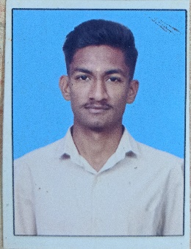**Krishna Jadhav**

**E-mail : krishnakj46@gmail.com**

**Mobile no : 8217700977**

**Address :** Navarasapura police quarters Atani Road Toravi, Vijaypur 586103 Karnataka

|  |
| --- |
|  |

**OBJECTIVE**

* Obtain an internship in an organization with best capabilities , skills

and knowledge

**ACADEMIC QUALIFICATION**

* 10th at Oxford IIT Olympiad School, Vijayapur

from with 76.1 %

* Diploma in computer science(1st ) at BLDEA’S SSM Polytechnic, Vijayapur

from DTE board with

* 1st year – 61.0%
* 2nd year – 59%

**PROFESSIONAL SKILLS**

* Python programming language
* Artificial Intelligence and Machine Learning
* DBMS basic
* Data structures with python
* Basics of JAVA

**PROJECTS**

**ML**

* House price prediction
* Cancer detection
* SEE marks prediction

**DL**

* Mnist digit dataset prediction
* Fashion mnist dataset prediction

**WORK EXPERIENCE**

* Fresher

**PERSONAL DETAILS**

* Father Name : Mahadev Jadav
* Mother Name : Indumati Jadav
* DOB : 06-09-2004
* Gender : Male
* Nationality : Indian
* Languages Known : Kannada , Hindi and English

**Place :** Vijayapur **Signiture :**

**Date :** 16-01-2023